  
  
  
**Parallel and Distributed Computing  
CSE4001**

***Lab Assignment 2***

Slot : L21+L22

Name : Kulvir Singh

Register Number : 19BCE2074

**Question 1 : OpenMP programs for addition, subtraction and multiplication using REDUCTION**

***AIM and PROCEDURE :***

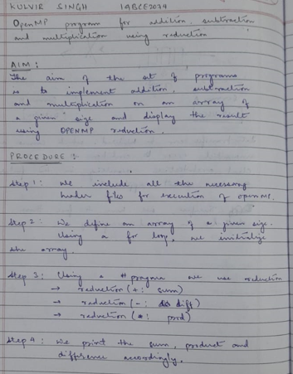

Code Screenshot - ADDITION

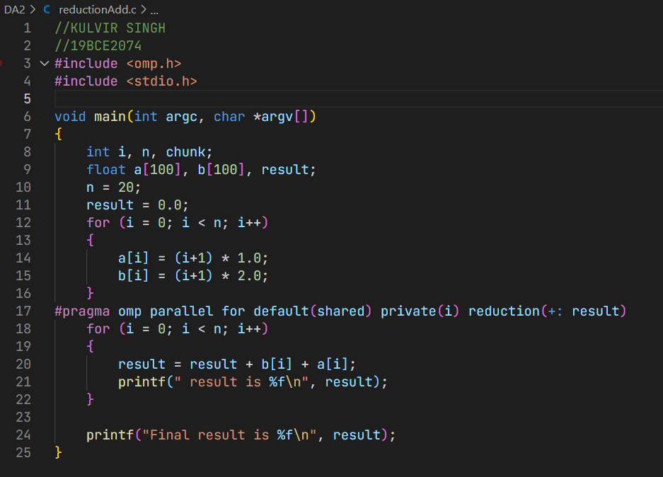

OUTPUT SCREENSHOT - ADDITION  
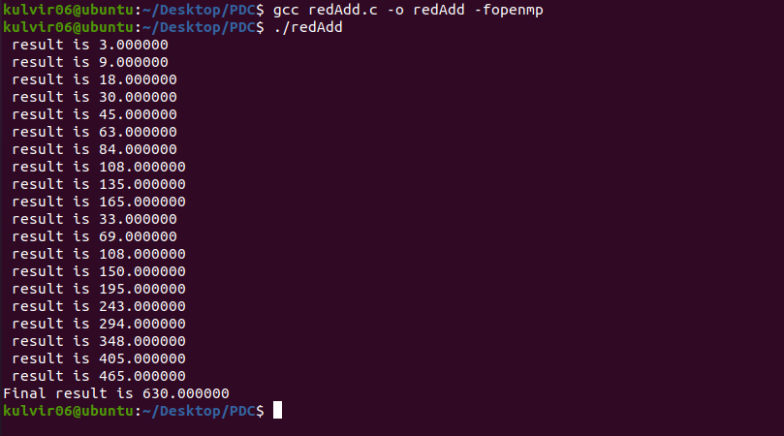

Code Screenshot - ADDITION

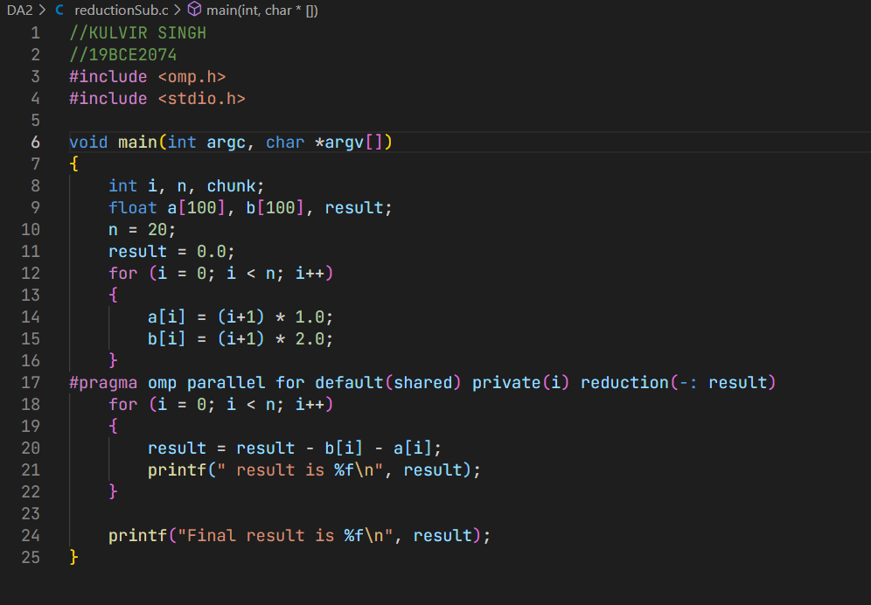  
  
OUTPUT SCREENSHOT - SUBTRACTION

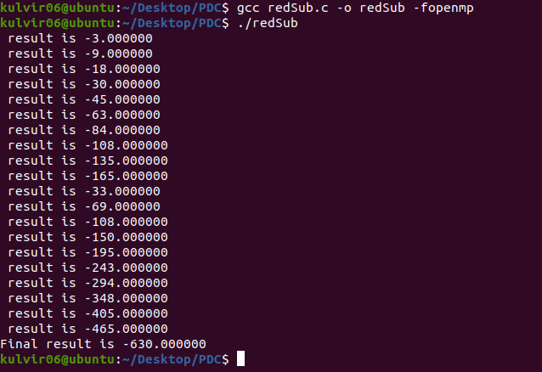

Code Screenshot - MULTIPLICATION

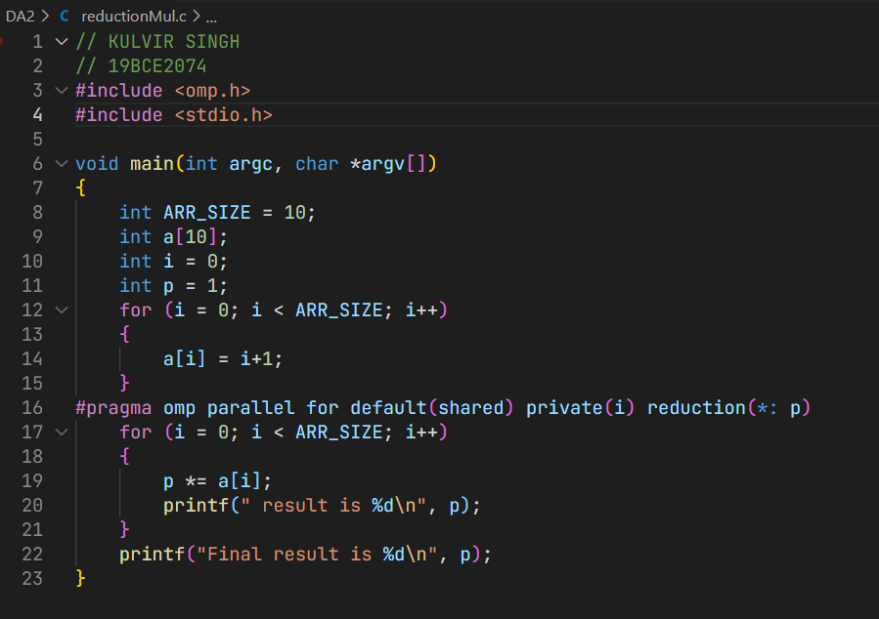  
  
OUTPUT SCREENSHOT - MULTIPLICATION

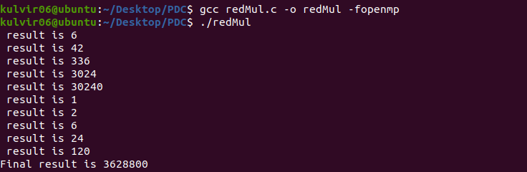

**Conclusion :**

The 3 codes and their respective outputs accurately calculate the sum, difference and product using REDUCTION

**Question 2 : OpenMP programs for addition, subtraction and multiplication using REDUCTION and SCHEDULING [CHUNKS]**

***AIM and PROCEDURE :***

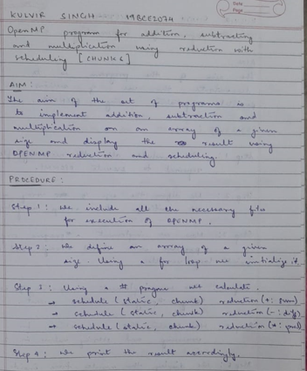

Code Screenshot - ADDITION

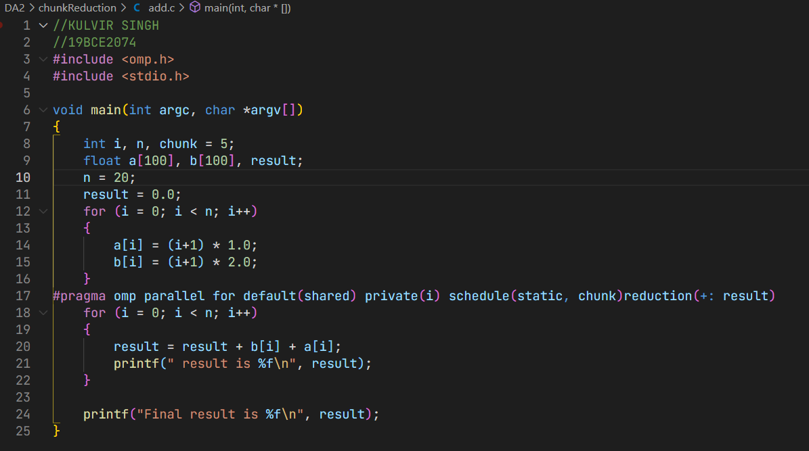

OUTPUT SCREENSHOT - ADDITION



Code Screenshot - SUBTRACTION

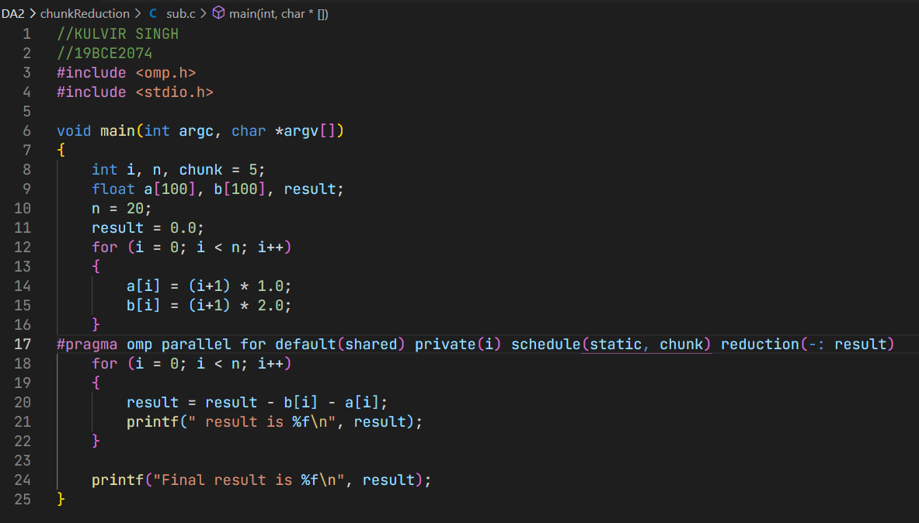

OUTPUT SCREENSHOT - SUBTRACTION



Code Screenshot - MULTIPLICATION

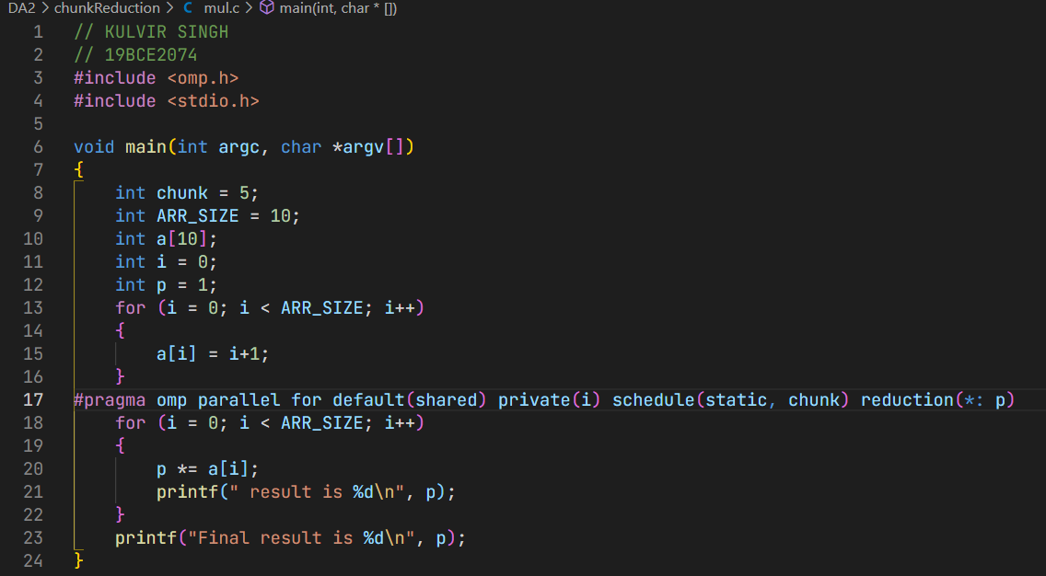

OUPTUT SCREENSHOT - MULTIPLICATION



**Conclusion :**

The 3 codes and their respective outputs accurately calculate the sum, difference and product using REDUCTION and SCHEDULING

**Question 3 : OpenMP program for vector dot product using REDUCTION and SCHEDULING [CHUNKS]**

***AIM and PROCEDURE :***

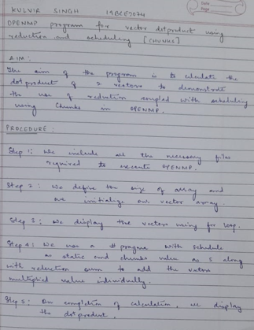

CODE SCREENSHOT

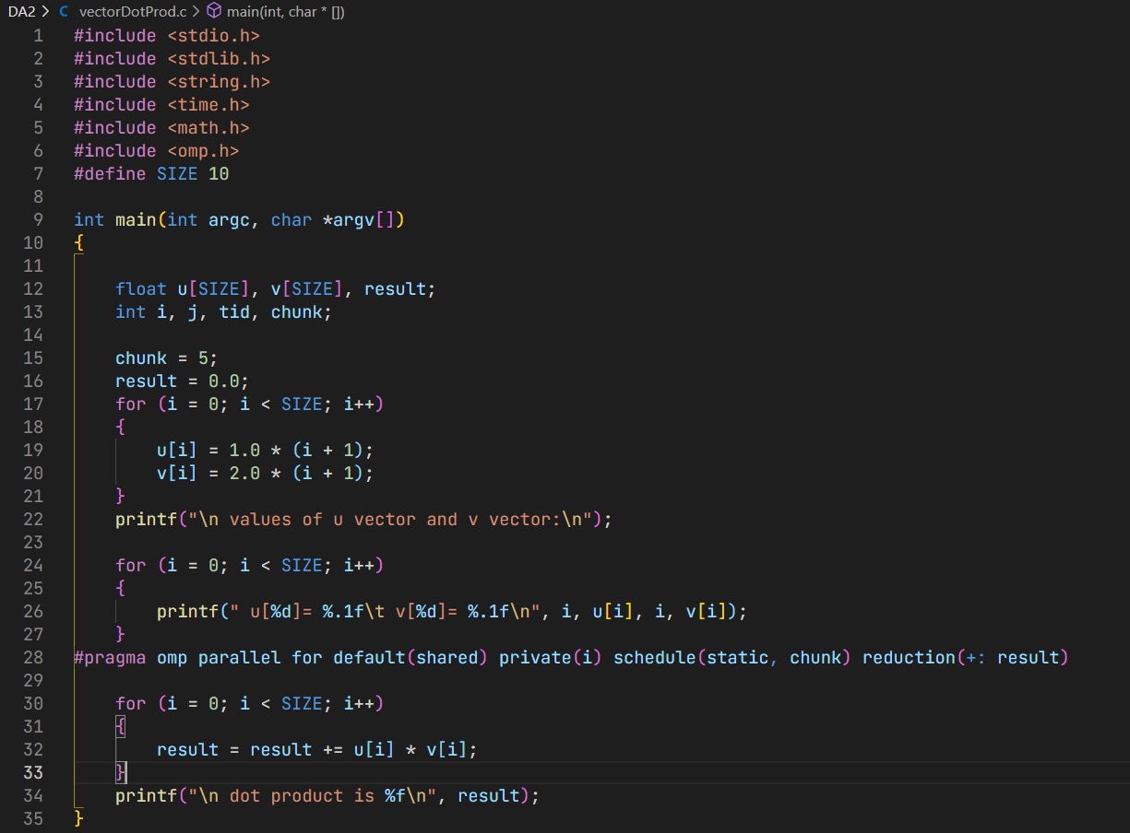

OUTPUT SCREENSHOT

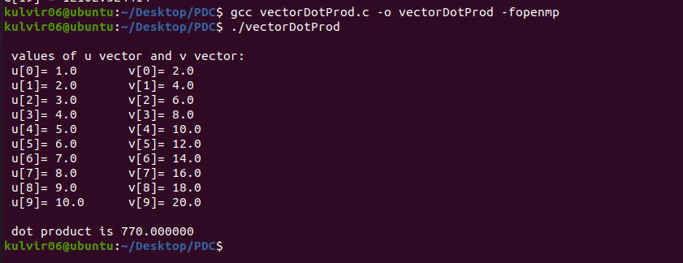

**Conclusion :**

The code and output accurately calculate the dot product of the 2 vector arrays using REDUCTION and SCHEDULING

**Question 4 : OpenMP program for implementing sections**

***AIM and PROCEDURE :***

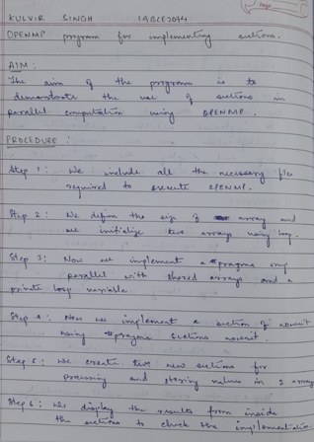

Code Screenshot

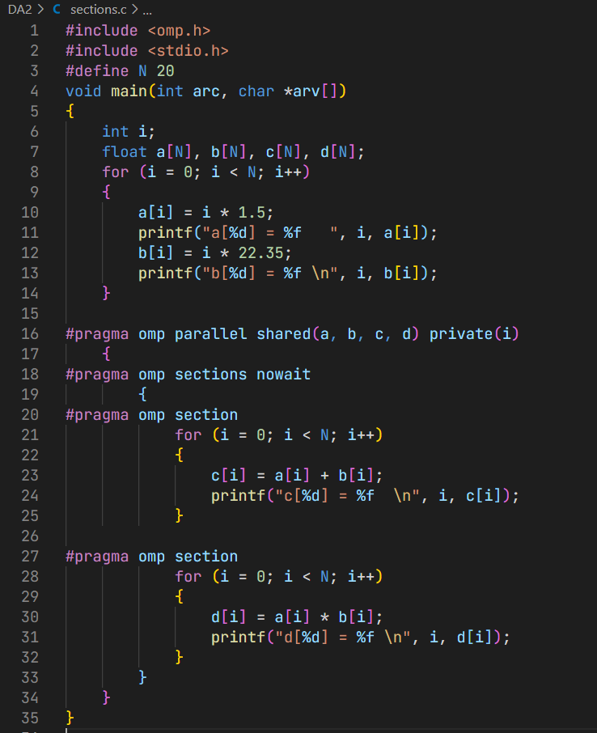

Output Screenshot

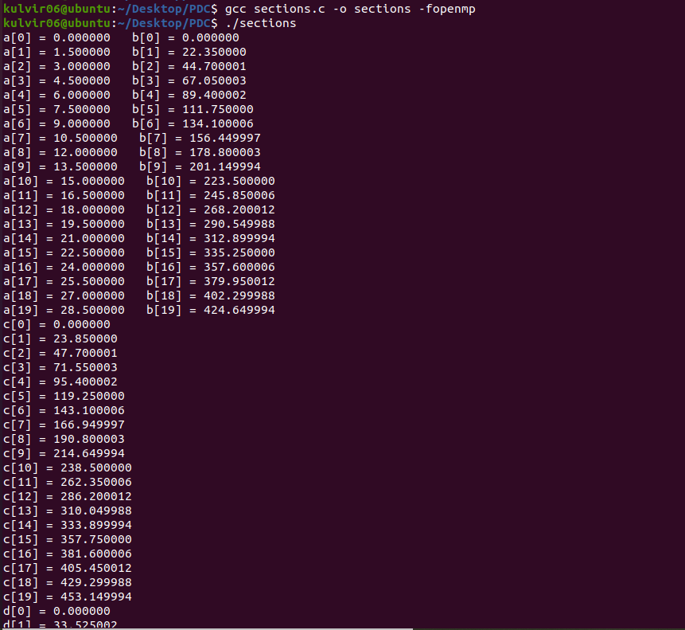

**Conclusion :**

The code and its output demonstrate successfully the use of sections and is justified by the output.